TEMPLATE — READ BEFORE USE
Delete this page before printing or emailing the guide to a tenant.
This is a reusable onboarding packet for a new tenant, built around the tenant portal that ships with this platform. Replace every bracketed placeholder — [Property Name], [Unit Number], amounts, dates, contacts — with your own details before sending it out. Sections you don't need (the checklist, a house-rule category that doesn't apply) can simply be deleted.
The layout is deliberately plain Word formatting throughout, so anything here — colors, the accent rule, table shading — is yours to restyle to match your own branding.

TENANT ONBOARDING GUIDE
Welcome to
[Property Name]

[Landlord / Management Company Name]
Prepared for [Tenant Name] · Unit [Unit Number] · [Move-in Date]
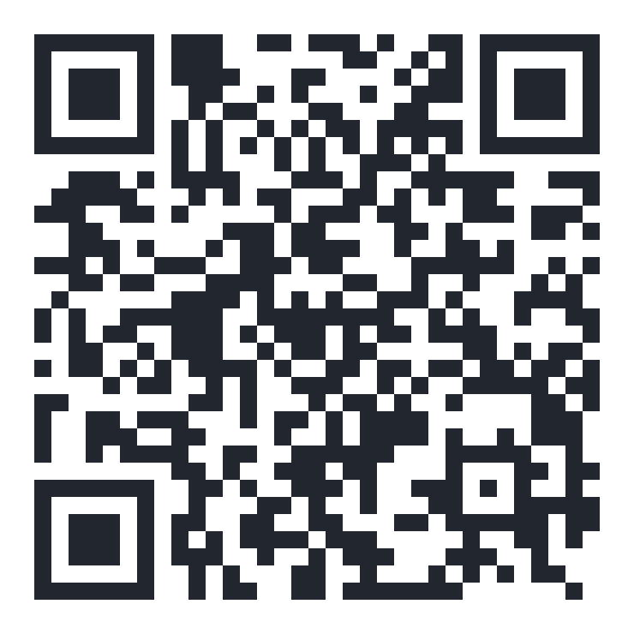
Scan to open your tenant portal

A warm welcome
Dear [Tenant Name],
Welcome to [Property Name] — we're glad to have you. This guide covers everything you need for a smooth start: how your tenancy is set up, how to pay rent and report repairs through your own tenant portal, the house rules for this property, and who to contact when you need us.
Keep this guide somewhere handy for your first few weeks. Once you're settled in, most of what's here becomes second nature — and everything stays available in your portal any time you need to check it again.
If anything is unclear, reach out — our contact details are on the last page.
Warm regards,
[Landlord / Management Company Name]

Your tenancy at a glance
The specifics of your tenancy, for quick reference — the full detail lives in your signed Tenancy Agreement.
Unit | [Unit Number], [Property Name]
Monthly rent | KES [Amount]
Rent due date | [Day] of each month
Security deposit | KES [Amount]
Lease start date | [Date]
Lease term | [e.g. 12 months, renewing]
Property manager / caretaker | [Name] · [Phone]

Move-in checklist
☐ Unit inspected together and any existing damage noted
☐ Water, electricity (KPLC token/meter) and any other meter readings recorded
☐ Keys and access cards received (record how many of each)
☐ Utility accounts transferred or set up in your name where applicable
☐ Emergency contacts saved to your phone
☐ Signed Tenancy Agreement received (available any time in your portal)

Paying your rent
Rent is paid through M-Pesa, in one of two ways — use whichever is more convenient each month. Both post straight to your account.

Option 1 — Instant prompt
From your tenant portal, tap Pay now. A standard M-Pesa PIN prompt is sent straight to your phone — enter your PIN and the payment is confirmed within seconds.

Option 2 — Pay from the M-Pesa menu
Prefer to pay directly? Go to M-Pesa → Lipa na M-Pesa → Pay Bill, and enter:
Business number (Paybill) | [Paybill Number]
Account number | [Your Account / Unit Code]
Your account number is shown on your portal's payment page — always use the one shown there, so the payment matches to your unit automatically.
Keep your receipt
Every payment — however you pay — appears on your portal's statement with a downloadable receipt. If a payment doesn't show up within a few minutes, contact the office with your M-Pesa message so it can be matched by hand.

Your tenant portal
Your portal is where your tenancy actually lives day to day — sign in any time at realty.reinstrade.com with the phone number or email [Landlord / Management Company Name] registered for you, or scan the code below to go straight there.
realty.reinstrade.com
- Check your current balance and full payment history
- Pay rent — instant prompt or Pay Bill, both covered on the previous page
- Download a receipt for any payment, or a full statement
- Report a repair, with a priority level, and track it through to completion
- Message the office directly and see replies in one place
- View or download your signed Tenancy Agreement any time
First login: use the “Forgot password” link to set your own password the first time you sign in.

House rules & community guidelines
The following apply to everyone at [Property Name]. Replace the placeholders with your own policies, and remove any category that doesn't apply to this property.
Quiet hours | [e.g. 10:00 PM – 6:00 AM]
Guests & visitors | [Your policy]
Parking | [Your policy]
Pets | [Your policy]
Garbage & recycling | [Collection day / location]
Alterations to the unit | [Your policy — e.g. requires written approval]
Common areas | [Your policy]

Maintenance, repairs & emergencies
Report any repair through your portal — include a short description and a priority level, and you'll be able to track it from request through to completion.
Emergency (fire, flooding, break-in) | [Emergency Number]
Caretaker / on-site contact | [Name] · [Phone]
Office (general enquiries) | [Phone] · [Email]
Utility provider (power) | [KPLC contact / area office]
Utility provider (water) | [Provider contact]
What counts as an emergency?
Anything that puts safety or the property at immediate risk — fire, flooding, a break-in, total power or water loss. For anything else, a portal repair request reaches us just as fast during office hours.

Acknowledgment
I confirm that I have received and read this Tenant Onboarding Guide, alongside my signed Tenancy Agreement, and agree to the terms and house rules described within.

Tenant name

Tenant signature · Date

On behalf of [Landlord / Management Company Name]

Signature · Date

